**MATA PELAJARAN : BAHASA INGGRIS**

**ULANGAN KENAIKAN KELAS**  
**KELAS : 5  SEMESTER 2**

**I. Choose the correct answer from these questions!**  
  
  
1. Tina    : What students are doing?  
    Nina   :......  
[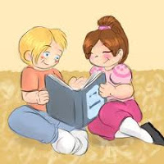](http://2.bp.blogspot.com/-0Kv2geDxlBk/UPbCyPSS6PI/AAAAAAAADws/jgt5nuW3kLE/s1600/read+a+book.jpg)   A. they are singing a song  
   B. they sang a song  
   C. they are read a book  
   D. they read a book  
2. Mima   : ....  
    Qia      : Yes, you may!  
  
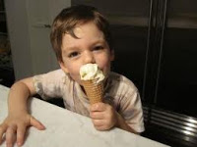  
 A. May I have ice cream?  
 B. Can I have candies?  
 C. May I have candies?  
 D. Can I have ice cream?  
  
3. It is ....  
[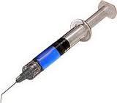](http://3.bp.blogspot.com/-P1WbHvcb9eo/UPbERDueANI/AAAAAAAADxE/QnruTW1im2A/s1600/jarum+suntik.jpg)  
   A. syringe  
   B. scissor  
   C. bandage  
   D. stethoscope  
4. Nina feel hurt on her throat. She has...  
    A. sneezing  
    B. backache  
    C. headache  
    D. sore throt  
  
5. Attika    : What time is it?  
    Nabylla  : It is...  
[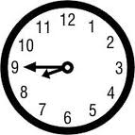](http://2.bp.blogspot.com/-CQqZ9vATwCU/UPbFNsk5ydI/AAAAAAAADxQ/II3MvjRDOgc/s1600/to+nine.jpg)A. half to nine  
B. half past nine  
C. quarter past nine  
D. quarter to nine  
6. A shape of coin is....  
    A. rectangle  
    B. triangle  
    C. circle  
    D. cube  
7. I got to airport. I go by....  
   A. airplane  
   B. bus  
   C. train  
   D. ship  
  
[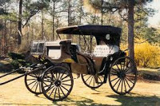](http://3.bp.blogspot.com/-XxVZv_8yjP4/UPbGMOvOdQI/AAAAAAAADxk/QIfG9z-NnQ0/s1600/cariage.jpg)8. This transportation mean is....  
    A. speedboat  
    B. motorcycle  
    C. carriage  
    D. pedicab  
9. You learn international language...subject  
    A. Arabic  
    B. English  
    C. Sundanese  
    D. javanese  
  
10. I like to play....  
[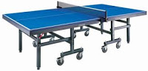](http://3.bp.blogspot.com/-nBPAL8ig8KA/UPbG7q7ZXEI/AAAAAAAADx0/fKoiHv9ZFiA/s1600/meja+tenis.jpg)    A. archery  
    B. table tennis  
    C. badminton  
    D. basketball  
11. A sport whice needs no stick is....  
     A. ice-skiing  
     B. golf  
     C. hockey  
     D. bowling  
  
12. Waiter      : Good evening, welcome to Bamima cafe!  
      Customer : ....  
     A. good morning, no!  
     B. good evening, thank you!  
     C. good evening, no thank you!  
     D. good morning, thank you!  
  
**For number 13-15, answer based on the following text!**  
  
**KOLO**  
Kolo is a dance from Bosnia. It is folk dance. It is a group of poeple holding each other by the hands around the waist dance. The instruments of the dance are accordion, frula (a traditional kind of a recorder), tamburica, sargija (harmonica)  
  
13. Kolo is from....  
     A. USA  
     B. Bosnia  
     C. Russia  
     D. Philippines  
  
14. .....play Kolo dance  
     A. one person  
     B. one boy  
     C. many poeple  
     D. A girl  
  
15. Frula is like....  
     A. harmonica  
     B. recorder  
     C. tamburica  
     D. trumpet  
  
16. This animal is....  
  
[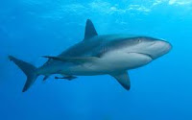](http://1.bp.blogspot.com/-R_SblqgA1no/UPbOtdISABI/AAAAAAAADyI/2PaWoxUbMcI/s1600/shark.jpg)     A. shark  
     B. seal  
     C. jellyfish  
     D. sea lion  
  
  
  
17. It is small, it can fly, it sucks (menghisap) human blood. It is....  
     A. mosquito  
     B. ant  
     C. bear  
     D. bee  
  
18. The followings live in the air....  
     A. owl, pigeon, crocodile  
     B. swallow, zebra, eagle  
     C. flamingo, woodpecker, canary  
     D. whale, cassowary, peacock  
  
 19. Novel is ....book  
     A. knowledge  
     B. news  
     C. story  
     D. sport  
  
20. Photosynthesis is a process of....  
     A. cooking food on leaf  
     B. cooking food on root  
     C. eating food on root  
     D. eating food on leaf

**Fill the blank!**  
1. Teacher  :.....  
    Student :    
  
[http://2.bp.blogspot.com/-hZXwk57jmYY/UPbXw8rTSNI/AAAAAAAADzU/RBHiZ0bEno8/s1600/1berdiri.jpg](http://2.bp.blogspot.com/-hZXwk57jmYY/UPbXw8rTSNI/AAAAAAAADzU/RBHiZ0bEno8/s1600/1berdiri.jpg)  
2. To cover wound (luka), doctor use....  
3. You learn how to pray to God in....  
4. David Backham is a...player  
5. Waiter      : The food is coming. Enjoy your meal!  
    Costumer : ....  
6. Someone to cooks foods and drinks, and works in the kitchen at a restaurant is....  
7. The music instrument is....  
  
[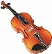](http://1.bp.blogspot.com/-VtsaHHdUGd0/UPbWNsIV41I/AAAAAAAADy4/LuJEcEWorMk/s1600/1violin.jpg)  
  
8. It is big. It lives in water, it is friendly. It can help people who drown (tenggelam). The animal is....  
9. It is like a book, it contains latest news and one theme (tema). Some of name are Kartini, Mangle and Gadis, it is....  
10. This flower is big. It smells bad, it can live the Bogor Botanical Garden, it is.....Arnoldi

Kunci Jawaban bagian I  
  
1.d  
2.c  
3.a  
4.d  
5.d  
6.c  
7.a  
8.c  
9.b  
10.b  
11.d  
12.b  
13.b  
14.c  
15.b  
16.a  
17.a  
18.c  
19.c  
20. a  
  
Kunci jawaban bagian II  
  
1.stand up  
2. bandage  
3. religion  
4. football  
5. tanks you  
6. chef  
7. violin  
8. dolphin  
9. megazine  
10 raflesia