Australia Indonesia Youth Exchange Program 2010/2011 (AIYEP)  In late February, 18 young Indonesians returned home to their towns in Indonesia after a four month experience that they will never forget. Their adventures began with living and working in Australia in November/December 2010.  Then in January 2011 they returned to Indonesia to experience life in South-east Sulawesi. They headed to Wangi Wangi, a beachside community of Wakatobi. It was here that the 18 Australian participants of AIYEP joined the program.  After 4 weeks in Wakatobi they all moved on to the city of Kendari. During their time in Wakatobi and Kendari the 36 AIYEPs gave cross-cultural performances to schools, worked with community groups, played sport with local youth and set up language clubs. Together they built strong people to people relationships with the local people plus even stronger relationships between themselves, AND between Indonesia and Australia.  AIYEP is in its 29th year – fantastic!  Check out KGI's Video Report and see all the action | 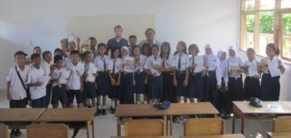
Journalists on Exchange from Australia with ACICIS  Have you ever thought about becoming a journalist? Journalism is a popular career choice both in Indonesia and in Australia. In early 2011, journalism students from Australia and New Zealand came to Indonesia in a program organised by the Australian Consortium for In-Country Indonesian Studies (ACICIS). Students were placed with a range of local and international media and development organisations including Tempo Weekly magazine, Metro TV, Radio Republik Indonesia, The Jakarta Globe and The Jakarta Post. KGI interviewed two of the students, Isabelle and Ben, in Jakarta.  Hear what Isabelle and Ben had to say about journalism as a career, and their experiences working in Indonesia, on KGI radio broadcasts in March/April and through KGI podcasts on the KGI website during March. | 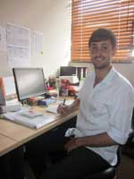  Press Release from the Australian  Embassy in Jakarta
S u r y a d i - working for the future!  Kang Guru Indonesia first met Suryadi Ningrat in Madura in 2005. As a keen young English teacher at Pondok Pesantren Al Amien he set up an English language club and joined the KGCC network of language clubs across Indonesia. KGI soon visited his club and the relationship really began. Suryadi went on to become actively involved with many other AusAID education activities including ISELP, LAPIS and ELTIS.  In December 2010 he went to Australia as a member of a LAPIS supported study tour group visiting the University of the Sunshine Coast and nearby schools in Queensland. Suryadi has been a Kang Guru Champion for 7 years. He has a wonderful command of the English language. Suryadi is now developing a very successful career in education. His dedication and genuine interest in teaching and in helping others to become better teachers and more successful students is very strong.  Just like KGI's other 6 Champions, Suryadi is highly motivated and enthusiastic about his future. | 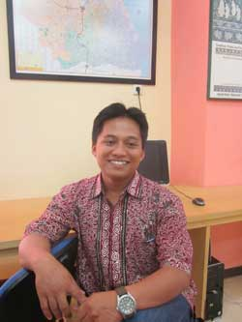  Check out KGI Champions videos  on the KG website and see what  they are doing in Indonesia
Alumni of Australia  In late 2010 KGI met with two young Australian Alumni in Jayapura, Papua. Kevin sat down with Natalis and Adel and did the very first Kang Guru video interview. Natalis (left) and Adel (right) talked about their time in Australia studying at university and their cross-cultural experiences in the land Down Under. Both women have returned to Indonesia to put their new-found knowledge and experiences to work for Indonesia's continuing development.  Both are Australian Development Scholarship awardees. Who knows, maybe you could also study in Australia with an Australia Indonesia Partnership scholarship. Start enquiring about the wide range of Australian scholarships NOW! For example, GOOGLE Australian Development Scholarships on the Web.  Perhaps you would you like to see the KGI video interview of Natalis and Adel for yourself? | 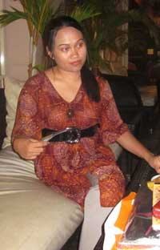
Irfan Bachdim  He is well-known in Indonesia and easily recognised, especially by football fans. Kevin interviewed IRFAN BACHDIM in Bandung in February. Irfan talked about his football career, how he now wants to live in Indonesia forever and how he feels about learning languages. Irfan was born in The Netherlands. His father is Indonesian and his mother is Dutch.  He grew up learning Dutch and English. Now, here in Indonesia he needs to start learning bahasa Indonesia. Like many Indonesian students of English, Irfan is a little shy about speaking Indonesian in case he makes mistakes. While living in Malang and training for football he is also studying BI. KGI is sure he will soon be a very confident user of bahasa Indonesia.  You can listen to Irfan's KGI interview on KGI radio across Indonesia in March/April 2011. KGI will soon have Irfan's interview podcasts on the KGI website.  By the way, Irfan was the very first person in Indonesia to receive a brand new KGI 'Sabang to Merauke' t-shirt. | 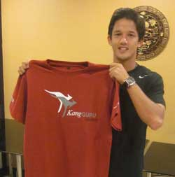

Irfan's Fans    (Klik tombol PLAY untuk mendengarkan dan  klik link mp3 untuk DOWNLOAD  segmen ke komputer anda) (MP3)  Why Irfan Loves Football  (Klik tombol PLAY untuk mendengarkan dan  klik link mp3 untuk DOWNLOAD  segmen ke komputer anda) (MP3)  Irfan's Advice to KGI Fans  (Klik tombol PLAY untuk mendengarkan dan  klik link mp3 untuk DOWNLOAD  segmen ke komputer anda) (MP3)  The Dream  (Klik tombol PLAY untuk mendengarkan dan  klik link mp3 untuk DOWNLOAD  segmen ke komputer anda) (MP3) | About Irfan Bachdim  (Klik tombol PLAY untuk mendengarkan  dan klik link mp3 untuk DOWNLOAD  segmen ke komputer anda) (MP3)  Irfan's Favourite Indonesian Foods  (Klik tombol PLAY untuk mendengarkan  dan klik link mp3 untuk DOWNLOAD  segmen ke komputer anda) (MP3)  Playing Football  (Klik tombol PLAY untuk mendengarkan  dan klik link mp3 untuk DOWNLOAD  segmen ke komputer anda) (MP3)  Irfan and Language  (Klik tombol PLAY untuk mendengarkan  dan klik link mp3 untuk DOWNLOAD  segmen ke komputer anda) (MP3)  Irfan's Favourite Music  (Klik tombol PLAY untuk mendengarkan  dan klik link mp3 untuk DOWNLOAD  segmen ke komputer anda) (MP3)

Thanks Indonesia  Indonesian engineers, Dr. Maryono (Ministry of Public Works), Dr Abdi (University of Gadjah Mada) and Dr. Sudinda ( Agency for Disaster Management), recently spent 10 days in Australia working in flood affected communities and at the GA offices in Canberra. GA is the Australian government's leading agency for understanding natural hazard risks. Indonesia also donated $1 million dollars to help victims of the floods.  The Australian Ambassador to Indonesia, Mr. Greg Moriarty said, "Indonesia's contribution to the appeal and offers of assistance are a reflection of the close support we provide for each other as friends and neighbours during times of natural disaster. Australia values and appreciates that relationship".  The heavy rains and floods, and a major cyclone later in February, caused tragic loss of life, and for thousands of Australians, their houses and businesses were severely affected by the devastating floods in Queensland, New South Wales and Victoria. | 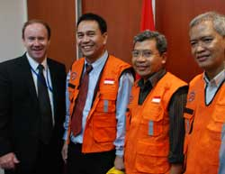  Read the Press Release from the Australian Embassy in Jakarta
Pronunciation problems: How do I say this?  English spelling can be very confusing. Sometimes teachers and learners are unsure how to pronounce certain words. What can you do? If you know a native English speaker then you can always ask them. You can also use the phonemic chart and a good dictionary to help you. Once teachers are sure of the pronunciation of certain words then they can use drilling to help their students. Look at the KGI website for some tips on using drilling successfully in the classroom.  The British Council has recently produced an online phonemic chart where you can actually hear the sounds by clicking on the phonemic symbols. | 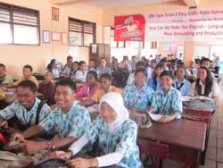

Have some fun with your students as they prepare to take exams.
Before the exam taking season begins, give them some tips so they revise well. Give them this list and ask them to choose the things they SHOULD do.
Study at the time you find you can do the most.
Don't study for more than thirty to forty minutes at a time.
Watch television for an hour a day to make you forget revising.
Take regular breaks.
Don't study late at night.
SMS or telephone your friends every hour with the latest gossip.
Relax before you sleep at night.
Watch movies till early morning to help you sleep.
Reward yourself with something nice after a day's revision.
Only revise two or three days a week and spend two or three days at the mall.
Eat healthy meals rather than snacks at your desk.
Drink lots of coffee to keep you awake.

Answers on KGI's Classroom Page - how did you do?

Getting Students To Speak
Teachers often ask Kang Guru for activities which will get their students speaking. Speaking can be quite scary for many students. Teachers need to encourage speaking in English as a natural part of the classroom activities and not something special to 'test' them. KGI has an activity that practices a grammar point in a 'safe' way and encourages the students to be creative.
Want to know more?

An active MGMP
Remember the story about Pak Khairul from Pasuruan and their very active MGMP? (See KGI's September 2010 bulletin).
Here are a few ideas for you to increase and sustain the membership of your MGMP -
* Hold regular meetings/workshops.
* Have a committee which is elected every six months/one year and encourage all members to accept a role in the committee.
* If possible make your schedule well in advance - perhaps make a bookmark with the dates and nature of the activities on it. Teachers can refer to it regularly and be prepared.
* Have a card made with each date printed on it. As the members attend each event they put a sticker/stamp on their card. At the end of the year members who have collected all the stickers/stamps can be entered into a grand draw for a prize.
For more ideas go to the KGI website
JOEYS  THe brand new, all new, JOEYS webpage is ready - exciting yeah? | 
Rocky McKenzie - Movie Star  Rocky McKenzie is a 16 year old indigenous Australian teenager. He is the star of the terrific movie 'Bran Nue Dae' which also stars KGI's friend and singer Jessica Mauboy. The movie was featured at the Australia Indonesia Film Festival in Jakarta earlier this year.  In late January this year Kevin met Rocky McKenzie, one of the stars of 'Bran Nue Dae'. They met in a hotel in Jakarta. Rocky was visiting Jakarta to attend the Australia Indonesia Film Festival.  Rocky McKenzie  (Klik tombol PLAY untuk mendengarkan dan klik link mp3 untuk DOWNLOAD segmen ke komputer anda) (MP3)  Language  (Klik tombol PLAY untuk mendengarkan dan klik link mp3 untuk DOWNLOAD segmen ke komputer anda) (MP3)   | Rocky talks about the movie  (Klik tombol PLAY untuk mendengarkan dan klik link mp3 untuk DOWNLOAD segmen ke komputer anda) (MP3)  'Something in The Water'  (Klik tombol PLAY untuk mendengarkan dan klik link mp3 untuk DOWNLOAD segmen ke komputer anda) (MP3)

KGI's Special 2011 Competition for SMP/SMA/SMK
Topic: How do YOU use KGI magazines/bulletins/materials in your Englishlanguage
classroom?
Length: Maximum 250 words - entries must be written/prepared by students
AND their teacher. Work together, okay?
Send entries by email to joeys@ialf.edu by the end of April 2011.

Grand Prize : Members of the KGI Team will vist your school in May, 2011 for a day
of fun, games and prizes.

