Water in Banten  We all know how important clean water is, don't we? It is VERY important. Right now, about 2,000 homes in Serang, Banten, have access to clean water for the first time. Serang is one of 35 Indonesian districts that have received grants to install new water connections. Australia is working closely with the Indonesian Government to administer the Water Hibah program.The grant is part of Australia's AUD$25 million commitment to increase piped water in poor urban communities, and to increase the number of households with sewerage connections. This support will give about 60,000 households across Indonesia new connections to piped water and up to 10,000 households sewerage connections. A further 400,000 Indonesians will have access to cleaner water and better sanitation as a result of the Water Hibah program. Cities and districts in Sumatra, Java, Kalimantan, West Nusa Tenggara and Sulawesi will benefit from this new water and sanitation initiative. As well as this grant program, Australia is helping local governments manage community water supply and sanitation utilities to ensure the sustainability of this development. | 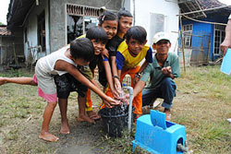
Commanders and crew of Royal Australian Navy ships, HMAS BALLARAT and HMAS PARRAMATTA, welcomed teachers and students from these 3 BRIDGE schools on board for a tour and lunch.  Have you ever seen a warship? Perhaps an Indonesian naval vessel in Surabaya harbour? On April 18th fifty very lucky students from MTsN Kediri 2, MI Miftahul Ulum Batu and MAN 3 Malang actually visited 2 Australian frigates in Surabaya. Commanders and crew of Royal Australian Navy ships, HMAS BALLARAT and HMAS PARRAMATTA, welcomed teachers and students from these 3 BRIDGE schools on board for a tour and lunch.  The students were so excited as they were shown all over the ships. KGI Champion Suryadi was there along with Kevin from KGI in Bali. The ships arrived with more than 350 crew for a three day visit to Indonesia from 16-19 April. During the visit, the crew participated in social and professional activities with the Indonesian Navy, further strengthening the relationship between the two countries. The relationship between the Royal Australian Navy and the Indonesian Navy is very strong, and is based on professional respect and friendship. Check out KGI's Australian Navy video a.s.a.p!    KGI and BRIDGE in Surabaya  with the Australian Navy (bilingual) | 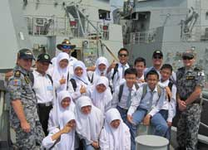  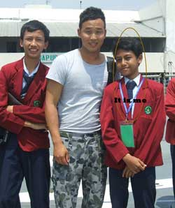
Kampung Olo before and after ...  In September 2010 Kang Guru Indonesia attended a reconstruction ceremony at SDN 19 Kampung Olo in Padang. The school had been destroyed earlier in the year by an earthquake. Through cooperation between AusAID and USAID, the school has since been re-built. In March 2011 KGI returned to SDN 19. What a beautiful school it is now. Kevin interviewed the Principal, Ibu Ribosita, and to hear the latest on the school (in Bahasa Indonesia) watch KGI's SDN 19 Kampung Olo video report. The students are very fortunate and their school and community are extremely grateful for the assistance they have received. Thanks to the Australia Indonesia Partnership and USAID.  SDN19 Kampung Olo Padang (during and after  reconstruction by AusAID and USAID) | 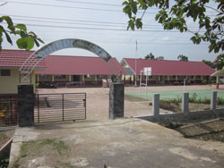
RRI Sabang (Sabang to Merauke with KGI)  On the front cover of the March 2011 KGI bulletin you may have seen the photograph of Kevin standing outside RRI Merauke in Papua. Well since then Kevin has been to RRI Sabang to celebrate the completion of a longtime KGI ambition – to make KGI truly Sabang to Merauke.  Traveling alongside Pak Samsul, Director of Australian Corner & Kangguru International Education Service  (KIES-ACEH), Kevin met with radio station staff, local English teachers and some of their students at RRI Sabang. So a big welcome to the KGI broadcast network!  KGI in Sabang - March 2011 | 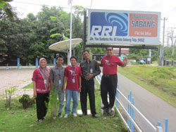

Muslim Exchange Program (MEP)
For many years KGI has been telling readers about a wonderful, annual program from the Australia Indonesia Institute (AII). The Muslim Exchange Program (MEP) allows both Australian and Indonesian Muslims to explore Islam in each other's countries.
A delegation of young Indonesian Muslim leaders, Fahd Pahdepie from Jakarta, Achmad Ubaidillah from Bogor, and Muzakkir from Balikpapan, departed for Australia in early April on a bilateral exchange program aimed at strengthening understanding in Islam and interfaith issues in both countries. This is the first of three delegations from Indonesia scheduled to visit Australia under the AII Muslim Exchange Program 2011.
In May, five young Muslim leaders from Australia will make a reciprocal visit to Indonesia to learn first-hand about Indonesia's diverse, democratic, and tolerant society and meet a wide range of different community representatives.
.

Drug and Explosive Detection
Are you concerned about drugs in your village, or terrorism in your country? The Australian Minister for Home Affairs, Mr. Brendan O'Connor, recently presented the Indonesian Directorate General of Customs and Excise with a special and powerful detector. This machine can pick up traces of explosives and narcotics. Now, isn't that great?

The LONSCAN 500DT dual purpose trace detection machine will be based in Jakarta. This $76,000 detection device will help Indonesian Customs officers to more easily and comprehensively detect traces of explosives and narcotics. Australian Customs and Border Protection officers will provide Indonesian Customs officers with training in the use of the machine, to ensure Indonesian officers can use the technology to its full potential.

CamTESOL in Cambodia  Is it possible for Indonesian teachers to have professional development training as well as an opportunity to travel overseas? The answer is YES! Along with 7 other teachers, Rudi Hartono, an English teacher of SMA Life Skill Teknologi Informatika in Palembang did just that (see below). He was recently sponsored to present a paper at the 7th CamTESOL Conference in Phnom Penh last February. Kevin and Ogi were also there to promote the work of KGI especially to Cambodian teachers. Find out more about this annual conference and other surprising stories from Cambodia on KGI video.  KGI at CamTESOL in Cambodia Feb. 2011 | 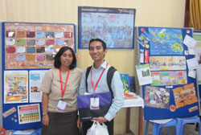
Community preparedness for Mount Merapi victims  Australia Indonesia Facility Disaster Reduction (AIFDR) and Gadjah Mada University (UGM) has formed a new partnership which focuses on the long-term safety of Indonesians living near Mount Merapi. This new research project will seek a better understanding of local knowledge, belief systems and ways of life in 30 villages in Yogyakarta and Central Java. Results will be used to guide future preparedness strategies and livelihood recovery plans.  "Volcanoes are incredibly difficult to plan for and devastating, as families lose loved ones and communities are displaced," said Dr. Matt Hayne, AIFDR co-director. "It is important we continue to prepare for future eruptions. A comprehensive preparedness strategy has to acknowledge, understand and use the generations of experience that local communities have from living with Mt Merapi for so long," added Dr. Hayne. UGM's Head of Anthropology, Dr Nicolas Warouw, believes this project will bridge the gap between the government and victims of Mount Merapi. | 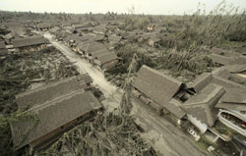

How many languages do you speak?
This is very interesting. When the KGI Team travels to different parts of Indonesia, they are always impressed by the fact that so many students in Indonesia can already speak several languages. Indonesia has hundreds of different ethnic groups and each of them speaks a different dialect or language. In some places, mainly the rural areas, the national language Bahasa Indonesia is not widely used, especially at home. In Lombok students might speak Bahasa Sasak at home. In Bandung it may be Bahasa Sunda or in Padang it could be Bahasa Minang. The children in the village where Kevin lives now all speak Bahasa Bali. When these children go to school they must also learn and use Bahasa Indonesia. So do you realize that when they also study English they are actually learning language number three (or maybe four).
Many experts agree that learning another language is easier when younger. Young learners learn multiple languages in a parallel path instead of translating from their native language. They learn to think in multiple languages at the same time and become fluent much more easily. Many students in Indonesia don't begin learning English formally until the age of 11 when they join SMP. Amazing! Maybe students should start learning English earlier?
So all you teachers and students out there who are learning English as a third or maybe even fourth language I think you should give yourself a pat on the back - memberi selamat pada diri sendiri. Well done.

After a recent workshop in Kupang KGI received this email from Pak Theodorus Sulon Suban
'The KGI teacher pack is so special, not only for me but also for my students. I teach grade 8 students at SMP Negeri 1 Kupang. I tried to use the 'Listen and Learn with Kang Guru Indonesia' and the teaching and learning became so interesting. The students enjoyed learning English very much and felt less tired than before. Besides that, the small posters awarded to active students gave them strong motivation to attend the lesson'.
Thanks Pak Theodorus. KGI loves to hear from teachers and students all over Indonesia. If you would like to read the rest of Pak Theo's email - www.kangguru.org/kgreintheclassroom.htm
Feedback from Bondowoso  KGI heard from Sunardi from Bondowoso, a student at Muhammadiyah University, Jember. He loves to get the KGI bulletins.  He even sent pictures of himself reading it in his office. A student with his own office? Find out more about this guy and his KGI bulletin by visiting KGI's website teacher's page -  www.kangguru.org/kgreintheclassroom.htm | 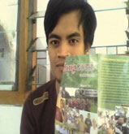
Pairwork and Group Activities  KGI hopes you sometimes have pair and group work activities  in your class. Do you? It is a great way for students to  use their English and exchange information without  feeling too embarrassed or nervous. It can be loads of fun too.  You should always create a balance between pairs,  groups and individual work. But how do you group them? Check out this KGI website link for some hints and tips on three ways to group students - www.kangguru.org/kgreintheclassroom.htm | 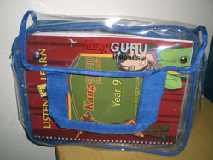
Joining a Teacher Association  According to a latest poll by the British Council, the most common reason for joining a teacher association is for -  - sharing materials and resources (37%)  - feeling part of an active teaching community 24%  - discussions with peers (14%)  - networking opportunities (13%) and  - receiving news about conferences and events with (11%)  So how do you feel about joining your local teacher association? If the MGMP is active and interesting then you will get a lot of benefits from joining AND supporting that group. | 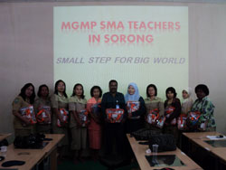
Three day intensive workshops for AIBEP school teachers  In March and April KGI presented 2 very special three-day workshops for teachers in the Bogor and Kupang areas. Over the three days the AIBEP English language teachers worked on how to write good lesson plans, how to give clear instructions in the English classroom, and how to best adapt materials so they become more communicative, plus many interactive warmers and fillers. They were introduced to practical, easy activities and games they can play with their students in the classroom. They used activities from the 'Listen and Learn with Kang Guru Indonesia SMP Package'.  Bogor and AIBEP Teacher Workshop - March 2011 | 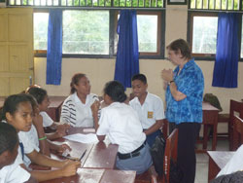

QUICK FIX
Watch your writing!
Similar sound, different spelling, different meaning!
quiet and quite
eg: I quite like a quiet area to rest in.
thinks and things
eg: She thinks she has so many things in common with her best friend.
mind and mine
eg: I don't mind if you use mine today
Look at the Joeys  They love riding bicycles to school. Not only is it healthy but also it is good for the environment. Should schools encourage students to cycle to school instead of riding motorbikes?  Ayu was shocked when she visited one of the schools in Denpasar recently to see the huge number of motorbikes on the basket ball court. Wow!  Do you think motorbikes should be banned (dilarang) at school? Without motorbikes schools could have more space for students to use especially for sport. What do you think?  TASK 1: Parts of a bicycle – how much do you know?  TASK 2: Joeys 'Bike to School' Photo Competition  Take a unique picture of you/your friends/a group of students going to school by bicycle and send it to joeys@ialf.edu before June 30th and win a special package from KGI including a fabulous, yellow KGI jas hujan.  TASK 3: the Joeys Special Edition 'Bike to School' badge.  Do you have a bicycle? Tell Joeys about your bicycle. What color is it? Where did you get it from? You could win a limited KGI edition Joeys 'Bike to School' badge.  TASK 4 : Do you know this sign?  GOOGLE it and answer some Joeys questions  Remember that Joeys is designed for SMP students   | 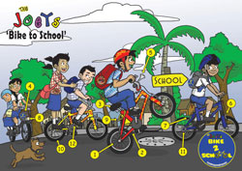  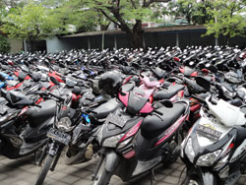  Go to the JOEYS website for full infomation on all Tasks - www.kangguru-joeys.org  