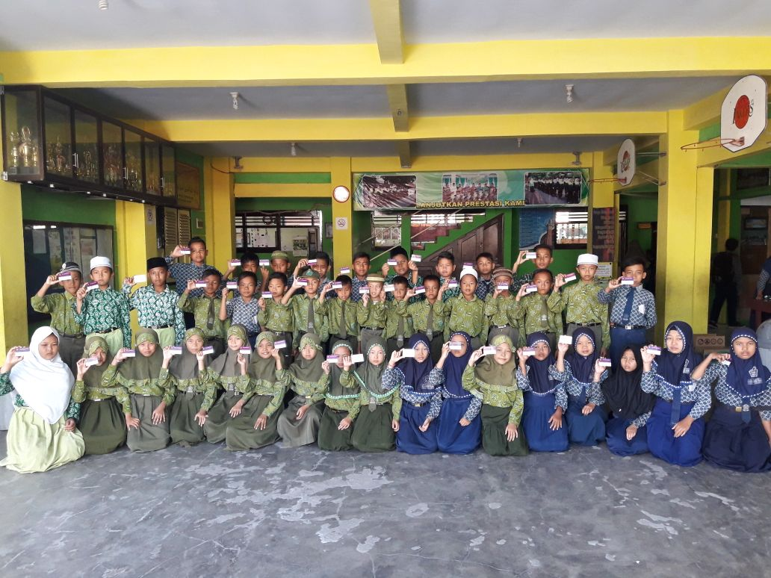

Foto siswa penerima Buffer PIP 2017